1. **Write a Python Program to find sum of array?**

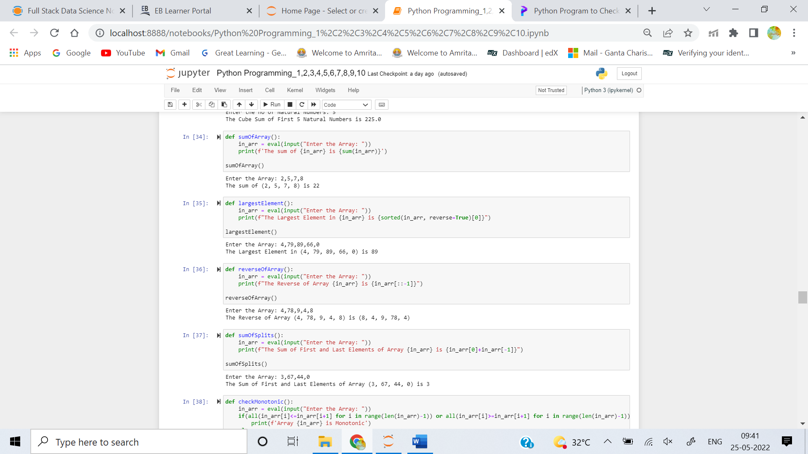

1. **Write a Python Program to find largest element in an array?**



1. **Write a Python Program for array rotation?**



1. **Write a Python Program to Split the array and add the first part to the end?**



1. **Write a Python Program to check if given array is Monotonic?**

